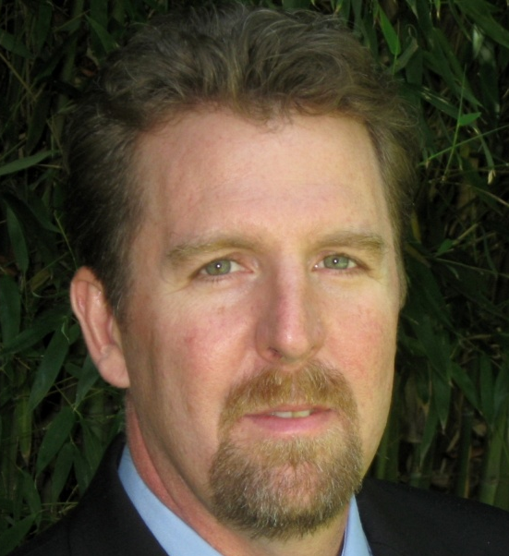
Rev. Ron Givens

The Real Consequences of Three Strikes

New Zealand visit, May 2010

Rev. Givens was Executive Director of the 600 Prison Chaplains in California, before most of them were fired under the new, harsher penal regime. He's a leader who is passionate about ending the three strikes law - like that currently proposed in New Zealand - and the inhumane conditions it has contributed to in US prisons. He is Political Director of UNION (United for No Injustice, Oppression or Neglect).

B. Cayenne Bird, Director of UNION says: “I am very proud to send him as our UNION Ambassador to warn your people of the impending doom that this draconian law will bring about should it pass”.

There is little doubt that the three strikes law currently before New Zealand’s parliament is a significant piece of legislation, and Ron provides graphic images of prison overcrowding and other consequences of budget shortages brought about by this policy in California.

Ron’s lecture moves from philosophies around justice through to the practical implications of this law, and he provides some startling insights that are certain to challenge even ardent supporters of the three strikes legislation.

Public meetings: AUCKLAND Wednesday 12 May
7 pm. Trades Hall, 147 Great North Road.

WELLINGTON Thursday 13 May
12.30 pm. St Andrews on the Terrace
5.30 pm. St Josephs Catholic Church, Brougham St, Mt Victoria

CHRISTCHURCH Friday 14 May
4pm. Oxford Terrace Baptist Church Hall.

Sponsored by the Howard League for Penal Reform in Association with the Edmund Rice Centre, Rethinking Crime and Punishment, and the Canterbury Community Law Centre.

