January 2018 Newsletter – Issue 25

Looking Forward
Kia ora koutou
I hope everyone has a relaxing and well deserved Christmas and New Year's break. Edmund Rice Justice Aotearoa-New Zealand is offering a number of activities to the wider Edmund Rice Network in 2018.

This year there will be street immersions ran in Auckland around the dates of July and November/December. These immersion experiences will run over the course of 3 days and are an excellent way for people to engage with community and engage in the reflection process.
In regards to Ethical Encounters, there will be a total of 7 for 2018, across Auckland, Christchurch and Dunedin. Potential topics that are currently begin explored include the refugee situation, cannabis law reform, student debt and the gender wage gap.
The monthly reflection programme will be starting up again in March. The Auckland Edmund Rice Reflection group gathers on Monday evenings on the first Monday of each month. The First Auckland reflection group started in March 2001.
If anyone has any questions regarding any of these events please feel free to contact me at campbell@erjustice.org.nz
Campbell Wood
Project Officer – Edmund Rice Justice Trust
Camp

Previous Project Officers
Previous Project Officer James Devereaux is currently working as a Geography and Social Studies teacher at Liston College. After his year as project officer, Jams completed a Masters in Teaching at the University of Auckland and also did the Edmund Rice Justice-training programme in Geneva. He was also deputy chair of Edmund Rice Camps Auckland. He currently is the Edmund Rice Networking person at Liston College, Accompanied by the Liston cricket 1st XI team to the Christian Brothers Cricket Week Tournament in Brisbane and is organising in March in Auckland, the Edmund Rice Schools student leadership programme for the student school leaders.

Sally Curtis is in her second year of a Masters of Education Psychology in Victoria University at Wellington. Sally is also just starting a new job at the University as a research assistant whilst continuing to be a teacher aide at Wellington College.

Boris Baptist has been appointed as a Trustee of the Edmund Rice Justice with the responsibility of the role of treasurer. At the end of last year, Boris graduated from the University of Auckland and has taken up a position at the Price Waterhouse Cooper accounting firm. Boris is also the currently deputy chairperson of Edmund Rice Camps Auckland.

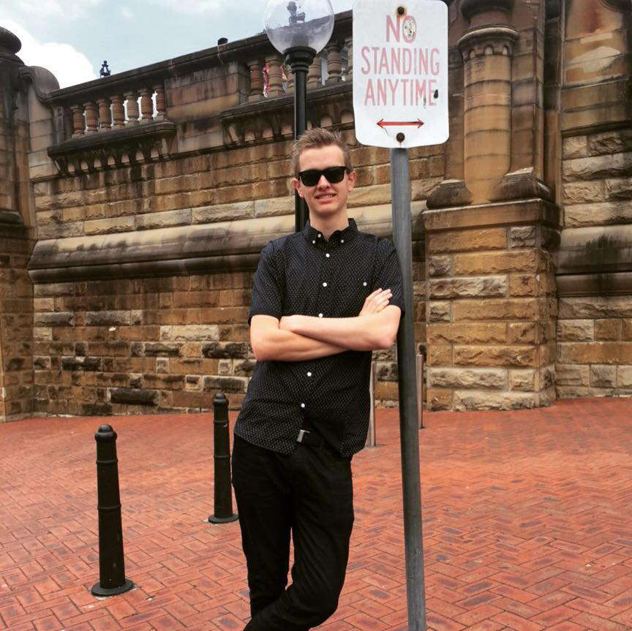
Our mailing address is:

campbell@erjustice.org.nz

unsubscribe from this list update subscription preferences

If you would like to use any part of our newsletter, please acknowledge the Edmund Rice Justice Trust.

why did I get this? unsubscribe from this list update subscription preferences

Edmund Rice Justice Aotearoa New Zealand ·

Our mailing address is:

campbell@erjustice.org.nz

unsubscribe from this list update subscription preferences

If you would like to use any part of our newsletter, please acknowledge the Edmund Rice Justice Trust.

why did I get this? unsubscribe from this list update subscription preferences

Edmund Rice Justice Aotearoa New Zealand ·

